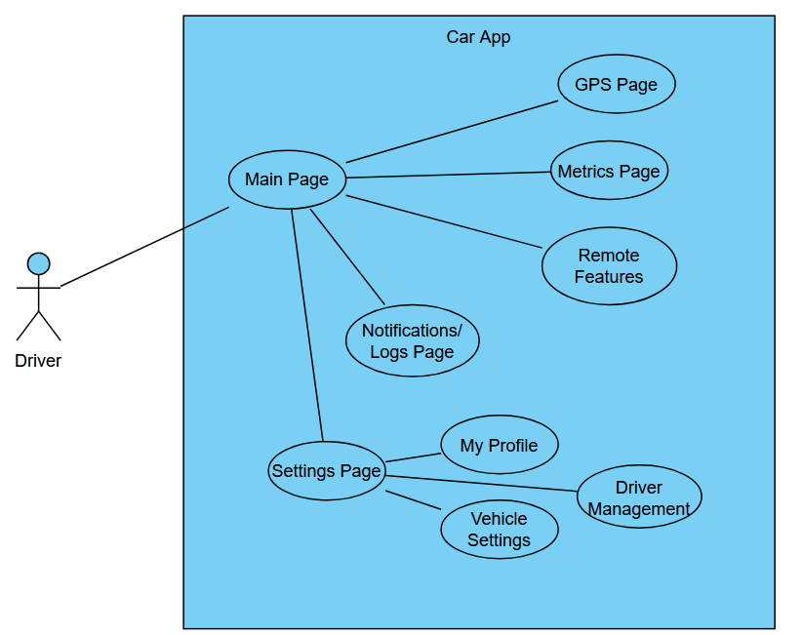

**Driver Management**

Users: Anyone with access to the app

Steps:

1.0. View existing driver profiles

2.0. Add new driver information using a username and email address

2.1. Exit and return to the settings page

**Main Page**

Users: Anyone with access to the app

Steps:

1.0. View Main page

1.1. Exit app

2.0. Use remote functionality (lock/unlock, start engine, stop alarm, open windows)

2.1. Navigate to GPS page for vehicle location

2.2. Navigate to Metrics page to view vehicle status

2.3. Navigate to Settings page for user and vehicle information

2.3. Navigate to Notifications page to view vehicle notifications